2025 Region II-4A

Spring Meet

Handbook

East Texas A&M University



East Texas A&M University

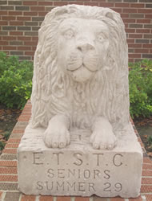Since 1889 East Texas A&M has been educating the people of Texas, and beyond. A member of the prestigious Texas A&M University System and located in Commerce, the university has campuses in Dallas, Mesquite, NavarroCollege and Midlothian, and conducts classes in McKinney, the Collin County Community College District, and at NortheastTexasCommunity College. Founder William Leonidas Mayo gave his name to Lion athletics and his creed of "ceaseless industry, fearless investigation, unfettered thought, and unselfish service to others" continues to this day.

The university began as EastTexasNormalCollege in Cooper, but when the campus was destroyed by fire in 1894 the university moved to its present location. When the State of Texas purchased the campus in 1917, our name was changed to EastTexasStateNormalCollege. In 1923, the school was renamed EastTexasStateTeachers College. The graduate program was added in 1935, and in 1957 the Legislature, recognizing we had broadened from teacher education, changed our name to East Texas State College. Following the inauguration of the first doctoral program in 1962, the name was changed to EastTexasStateUniversity, in 1996 became A&M-Commerce, and in 2024 was renamed at East Texas A&M University.

[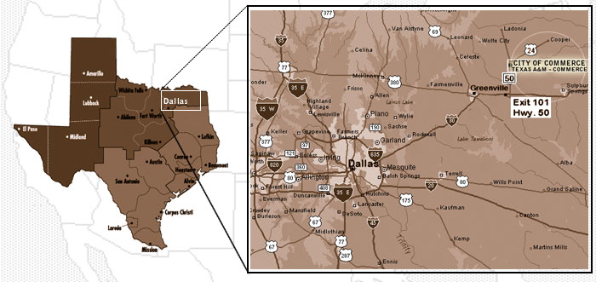](http://www.tamu-commerce.edu/reccenter/facilities_alpha/pics/facility_images/m)

Academic Entries

(Should be certified through the UIL online System)

FEES *(Instructions can be found on page 15.)*

In order to expedite the payment process for the Region II–4A 2025 Spring Meet, the Regional Director has authorized the following flat rate fee schedule:

Academic entry fee per district $ 3,000.00

Payment Requirements

The District Spring Meet Chair for each district represented in Region II–4A will collect and submit the fees for that district. **Payments are due by April 3, 2025.** Please include all schools in your district when making the payment online. District Academic Payment Instructions located on page 15 of this handbook.

A list of absent contestants will be reported to the state UIL office from each academic event. It is extremely important that you notify the regional director in advance if a contestant will be unable to attend the regional competition.

All academic questions should be directed to Katy King, [katykinguil@gmail.com](mailto:katykinguil@gmail.com)

Contact information

Katy King

UIL Academic Director

(903) 366-3569

[katykinguil@gmail.com](mailto:katykinguil@gmail.com)

General Information

Academic UIL Headquarters

The Academic UIL Headquarters will be located in TBD.

Participant Requirements

We have a few requirements that we ask our participants to follow:

* The designated administrator of each school who has a qualified representative is responsible for knowing the dates for the meet and the scheduled time for each contest or event. All events will start at exactly the time posted. A roll call will be taken for each contest or event. Participants will NOT be allowed to enter the contest after the contest has begun.
* Each school must follow the Spring Meet Code as outlined in this handbook and the Constitution and Contest Rules of the University Interscholastic League which encourages all participants to compete in all contest in the spirit of fairness, good sportsmanship and high ethics.
* Participants should accept decision of officials or judges, treat officials with respect, treat opponents as guests and should put sportsmanship above victory. Violation of the code may result in probation, disqualification, or suspension of participants and/or schools.

Coach and participant Registration

All coaches, school officials and participants are asked to register upon arrival at UIL Headquarters .

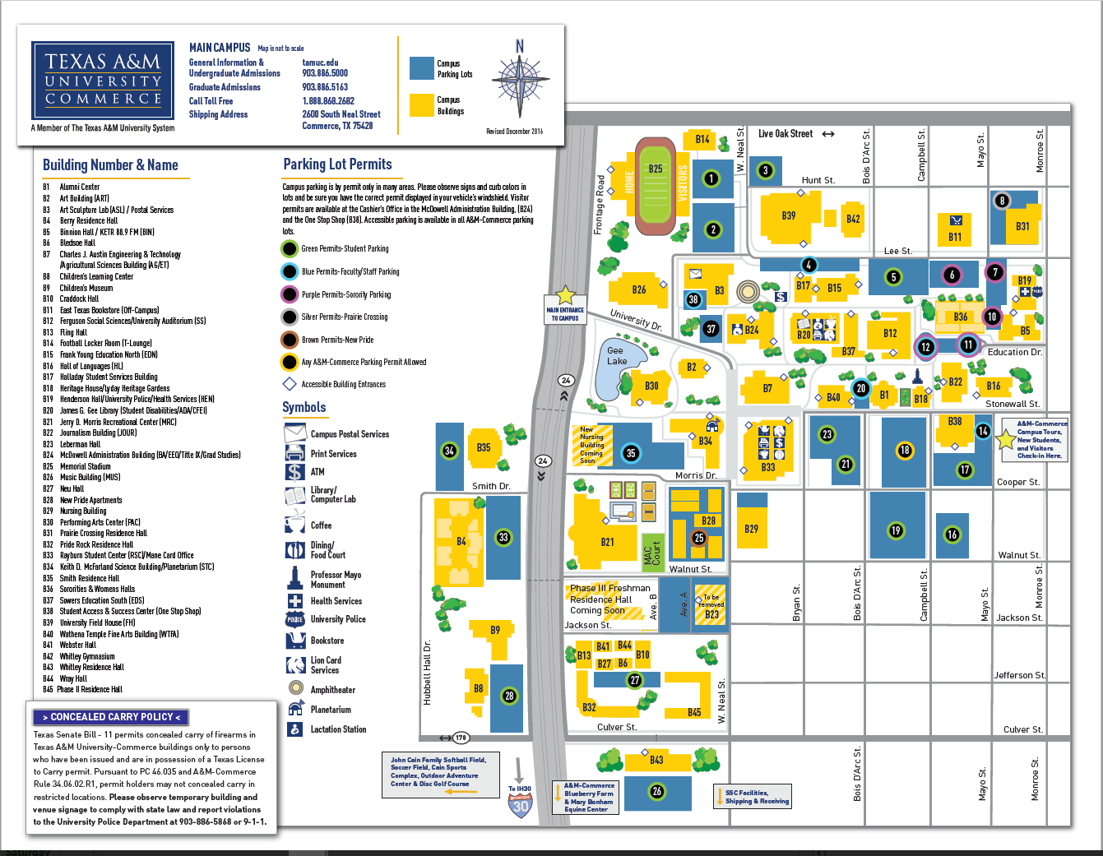

Awards Information

Contest Results and Medals

The results/verification of the academic contests on Saturday, April 26will be posted in UIL Headquarters.

Speech event results/verification/medals will be held in the Speech contest building (TBD).

Participants, coaches and other school officials are urged to attend all verification periods. Please ask judges to remain in the room during verification periods. The regional meet directors not responsible for contacting participants who fail to pick up their medals/awards. After the final results are posted, the participant or a school representative may pick up the awards at the awards pick up station.

All individual winner medals, **except for Speech Events**, will be awarded following EACH event at the UIL Headquarters once the scores have been verified and declared official.

UIL State Meet Information

Austin, Texas

Information regarding the 2025 UIL Academic State Meet is posted on the UIL web site, [www.uiltexas.org](http://www.uiltexas.org). Except for Lincoln-Douglas Debate coaches’ packets for advancing Lincoln-Douglas Debaters, information packets will not be mailed to schools or handed out during the regional meet verification meetings or awards ceremonies. LD winning coaches should make certain they pick up LD information packets. Note: Each contest package does include information cards for each student winner.

Coaches and participants must go to the UIL web site for tentative schedules, University of Texas campus map and parking information.

Area Restaurants

(Commerce, Texas 75428)

|  |  |  |
| --- | --- | --- |
| **Braum’s Ice Cream & Dairy**  1589 Hwy. 50  (903) 886-6242 | **Chicken Express**  2200 Live Oak  (903) 886-8200 | **Domino’s Pizza**  2200 Live Oak  (903) 886-2116 |
| **Lone Star Eatery**  Hwy. 50 (near Wal-Mart)  (903) 886-2163 | **Los Mochis Mexican**  Lee Street  (903) 886-8200 | **Luigi’s Italian Café**  1615 State Highway 50  (903) 886-2000 |
| **LuLu’s Burgers**  803 Culver Street  (903) 886-3888 | **McDonald’s**  2102 Live Oak  (903) 886-7771 | **Maria’s Kitchen**  1940 Live Oak St  (903) 246-3677 |
| **Pizza Hut**  1920 Live Oak  (903) 886-9600 | **Rayburn Student Center**  Food Court (details below)  TAMU-C | **Sonic Drive-In**  Hwy. 50  (903) 886-7166 |
| **Subway**  1940 Live Oak  (903) 886-7827 | **Sweeties Donut Shop**  1903 Live Oak  (903) 886-6111 | **Taco Bell**  1613 Hwy 50  (903) 886-1640 |
| **Dos Laredos**  1229 Washington St (Downtown)  [(903) 886-1234](javascript:void(0)) |  |  |

Rayburn Student Center

(#33 on Campus Map)

The East Texas A&M University cafeteria is a great place to eat and socialize with your teammates. Serving breakfast, lunch and dinner, meals are carefully planned by Sodexo and served to you buffet all you can eat style. We will also have Chick Fil A open in the Rayburn Student Center for lunch.

Area Lodging

|  |  |  |
| --- | --- | --- |
| **Magnuson Hotel Commerce**  2207 Culver Street  Commerce, Texas75428  (903) 886-4777  [hiecommerce@gmail.com](mailto:hiecommerce@gmail.com) | **Hampton Inn & Suites Greenville**  3001 Kari Lane  Greenville, Texas75402  (903) 457-9200  [www.hamptoninn.com](http://www.hamptoninn.com) | **Holiday Inn Express Greenville**  2901 Mustang Crossing  Greenville, Texas75402  (903) 454-8680  [www.hiexpress.com](http://www.hiexpress.com) |

Academic Event Schedule

Lincoln-Douglas Debate

Saturday, April 26, 2025

Roll Call 7:30 am TBD

Round #1 8:00 am TBD

Round #2 9:00 am TBD

Round #3 10:00 am TBD

Quarter Finals 2:00 pm TBD

Semi-finals 3:00 pm TBD

Finals 4:00 pm TBD

Academic events

Saturday, April 26, 2025

Accounting

Contest 11:30 am – 1:00 pm McDowell Admin. 109

Grading McDowell Admin. 106

Calculator Applications

Contest 9:00 am – 10:00 am AG/IT 253

Grading AG/IT 233

Computer Science Written

Contest 2:00 pm – 3:00 pm TBD

Grading TBD

Computer Science Hands-on Programming Component

Set up 3:00 pm – 4:00 pm TBD

Dry Run 4:00 pm – 4:30 pm TBD

Contest 4:30 pm – 6:30 pm TBD

Current Issues and Events

Contest 8:30 am – 10:00 am Education South 104

Grading Education South 101

Journalism

Copy Editing 11:00 am-11:30am Education South 104

News Writing 11:30 am – 12:30 pm Education South 104

Feature Writing 12:30 pm – 2:00 pm Education South 104

Editorial Writing 2:00 pm – 3:00 pm Education South 104

Headline Writing 3:00 pm – 4:00 pm Education South 104

Grading Education South 101

Literary Criticism

Contest 4:00 pm – 6:00 pm AG/IT 238

Grading AG/IT 233

Mathematics

Contest 3:00 pm – 4:00 pm McDowell BA 109

Grading McDowell BA 109

Number Sense

Contest 8:00 am – 8:30 am McDowell BA 109

Grading McDowell BA 258

Ready Writing

Set Up 8:00 am – 8:30 am AG/IT 238

Contest 8:30 am – 11:00 am AG/IT 238

Grading AG/IT 238

Science

Contest 11:30 am – 2:00 pm TBD

Grading TBD

Social Studies

Contest 2:00 pm – 4:00 pm McDowell BA 257

Grading McDowell BA 106

Spelling and Vocabulary

Contest 11:30 am – 2:00 pm AG/IT 253

Grading AG/IT 253

Informative Speaking

Roll Call/Draw 11:30 am TBD

Preliminaries 12:00 pm – 2:00 pm TBD

Draw 4:00 pm TBD

Finals 4:30 pm – 6:30 pm TBD

Persuasive Speaking

Roll Call/Draw 11:30 am TBD

Preliminaries 12:00 pm – 2:00 pm TBD

Draw 4:00 pm TBD

Finals 4:30 pm – 6:30 pm TBD

Poetry Interpretation

Documentation 7:30 am – 8:00 am TBD

Preliminaries 8:00 am – 11:30 am TBD

Finals 2:00 pm – 4:00 pm TBD

Prose Interpretation

Documentation 7:30 am – 8:00 am TBD

Preliminaries 8:00 am – 11:30 am TBD

Finals 2:00 pm – 4:00 pm TBD

Speech Events

General Instructions and Information

Lincoln-Douglas MUST check in at the Lincoln Douglas contest area in the Nursing & Health Science Building

Prose, Poetry, Informative and PersuasiveMUST check in at the Speech contest area in Nursing & Health Science Building.

**Lincoln-Douglas Debate: Saturday, April 26, 2025.**  All judges for Lincoln Douglas will be provided by East Texas A&M University. Coaches may be asked to serve as timekeepers.

**Prose, Poetry, Informative and Persuasive: Saturday, April 26, 2025**. All judges for Prose, Poetry, Informative and Persuasive will be provided by East Texas A&M University. Coaches may be asked to serve as timekeepers.

All judges are required to stay until all ranks have been verified.

***Members of the RAC will conduct prose/poetry documentation check online prior to the contest. If you do not provide documentation and get cleared prior to the Saturday of competition, you must provide the documentation to a member of the RAC in the prose/poetry assembly room and be cleared by 7:30 AM. Please have the documentation forms from the UIL website completed when you arrive. Failure to have proper documentaqtion Saturday morning will lead to disqualification.***

***The speech event finals may be moved up, pending cross entries****.*

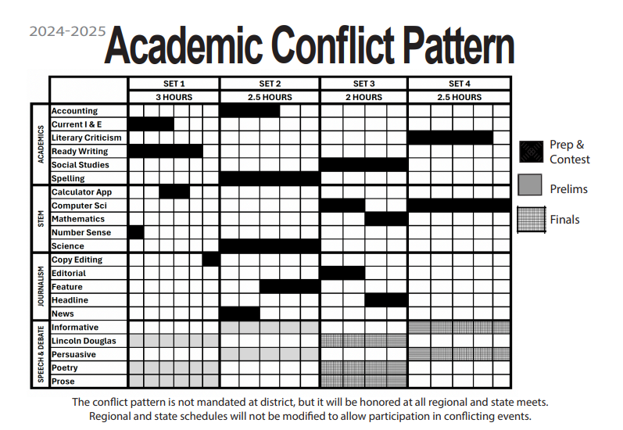

University Information

President Rudin

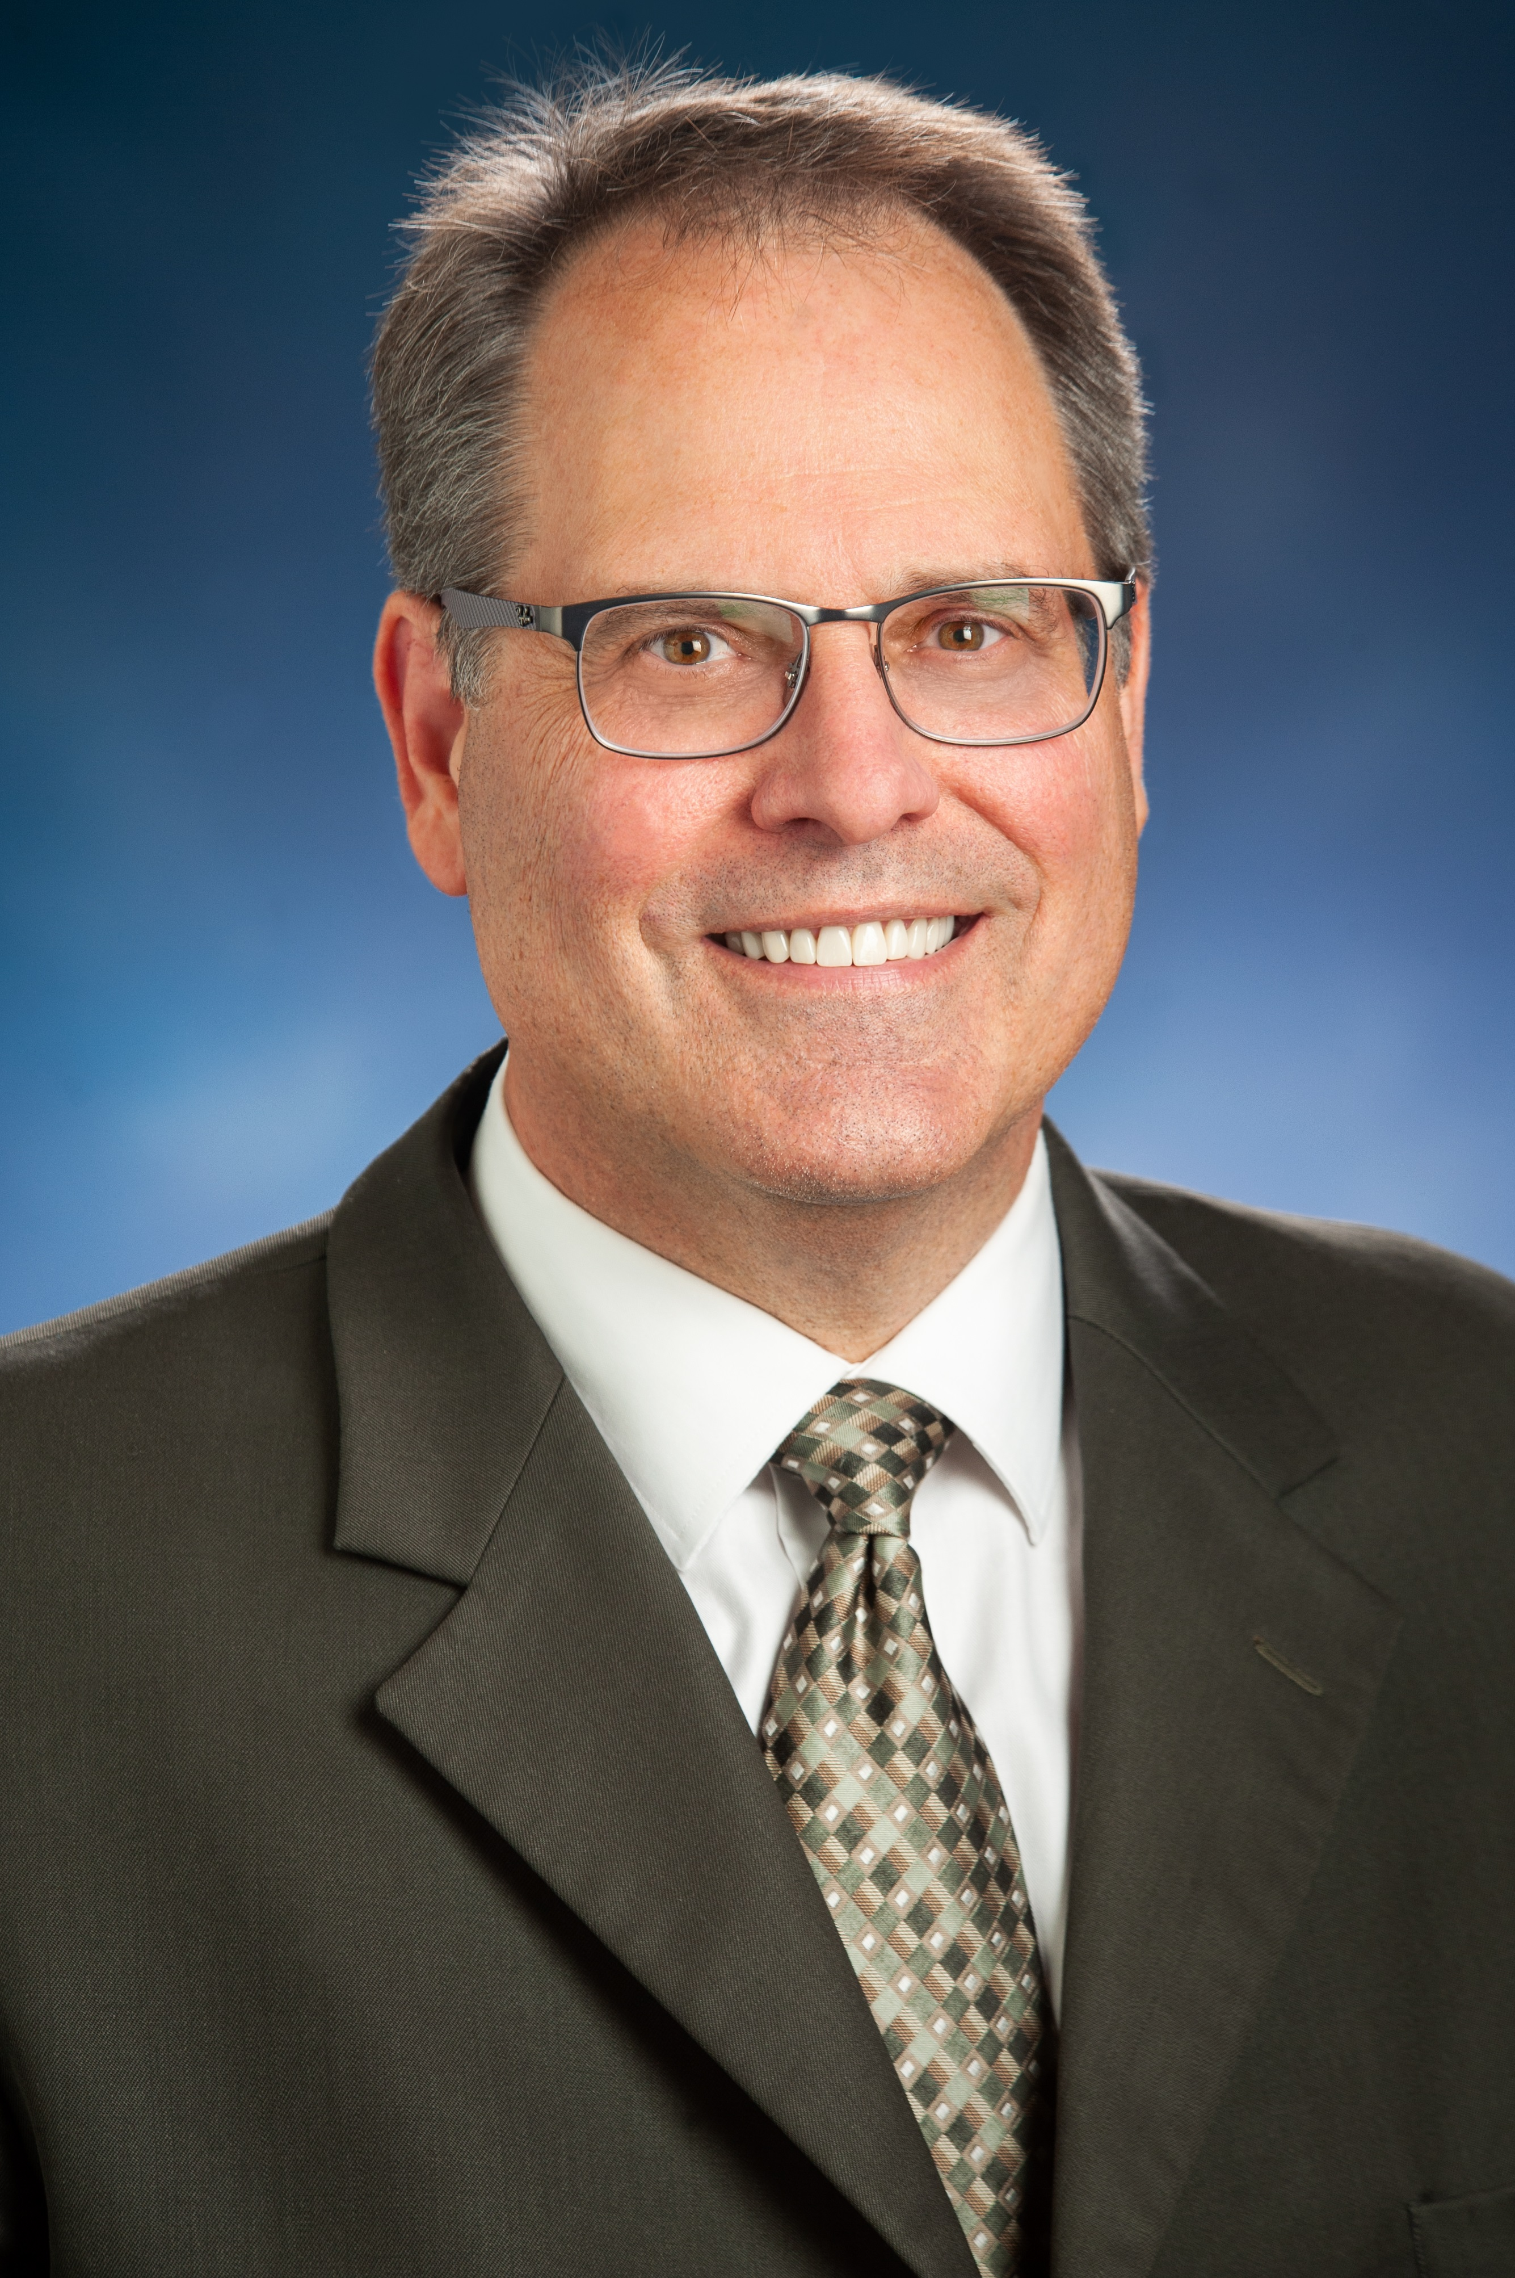Dr. Mark J. Rudin became the 13th President of East Texas A&M University August 16, 2018, and immediately began work on the following strategic initiatives: student success, welfare of faculty and staff, expanding research, economic development, achieving distinction/branding, innovative and civil campus culture, and fiscal responsibility and sustainability.

Prior to assuming the presidency at East Texas A&M, Dr. Rudin served as the Vice President for Research and Economic Development at Boise State University. Over the course of 11 years there, he played a central role in expanding the research activity at the university. Before Boise State, Dr. Rudin served at the University of Nevada, Las Vegas (UNLV) as the Associate Vice President and then as the Senior Vice President for Research prior to becoming the Interim Vice President for Research and Graduate Dean. Other previous positions include Technical/Administrative Assistant with the U.S. Department of Energy (DOE), senior Program Specialist/Project Engineer with EG&G Idaho, Inc., and instructor in the Department of Health Physics at Idaho State University.

He holds bachelor’s, master’s and doctoral degrees from Purdue University, with a concentration in Health Physics.

Dr. Rudin’s wife, Elizabeth “Libby” (Schreiber) Rudin, is a fellow Purdue University graduate and chemist. They are the proud parents of Noah, Mia and Izzy, and reside on campus in Heritage House, the historic home of East Texas State University and East Texas A&M presidents.

Rayburn Student Center

(#33 on Campus Map)

Opened in 2009, our state of the art student center has many built in features such as the lighting systems, water free urinals, materials used in furniture and a state of the art lighting control system that is based on an astronomical clock set for our latitude and longitude. Safety systems are being put into place and a major convenience factor – lockers with electrical outlets so you can recharge your electronics while dining, meeting or attending a function.

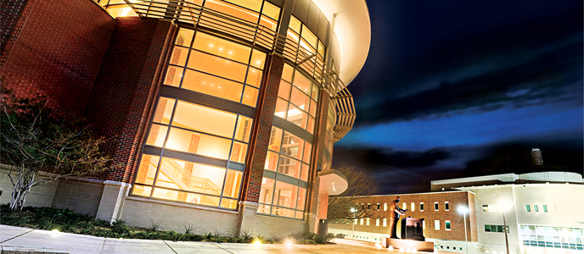Sam Rayburn, who graduated in 1903 from what was then East Texas Normal College, fondly remembered his alma mater as a place that gave even the poorest students a chance to succeed. Rayburn himself swept floors at the college to earn the education that later enabled him to serve as Speaker of the U.S. House of Representatives longer than anyone else.

University Information

Planetarium

(#34 on Campus Map)

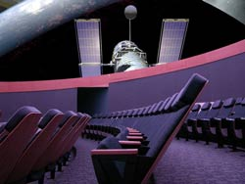

East Texas A&M University is proud to announce the opening of its state-of-the-art planetarium. The planetarium has a 40-foot dome and a Digistar 5 high resolution digital projection system which fills the dome with sights and sounds beyond imagination. The planetarium's 87 reclined seats immerse the audience in a space environment filling their vision and appearing to take them beyond the confines of the Earth.

The planetarium is open to the public on Fridayat 7 & 8 PM; please call (903) 468-8652 for a recording specifying specific dates and information. Each show lasts about 45 minutes and contains a view of the current night sky where constellations, stars and planets are shown.  For more information, please visit [www.tamuc.edu/communityOutreach/planetarium/](http://www.tamuc.edu/communityOutreach/planetarium/).

Morris Recreation Center

(#21 on Campus Map)

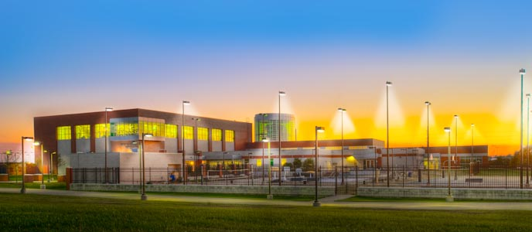The Morris Recreation Center is the focal point of the East Texas A&M campus and serves as the "heartbeat" of student life.

The $12 million dollar state-of-the-art Morris Recreation Center, opened in June 2003. The Morris Recreation Center includes: 45-foot climbing rock, 3-lane jogging track, 4 racquetball courts, 2 basketball courts, large fitness room with cardiovascular and weight equipment, aerobics room, classroom, snack area, and locker rooms. The outdoor area includes: heated leisure pool (beach-type entry, fountains, water tunnel, current channel, bubble jet benches, 3-lap lanes), 2-tier hot tub with water fall, 2 sand volleyball courts, 2 basketball courts, picnic tables, BBQ pits, and a sunbathing area.

Alumni Center

(#1 on Campus Map)

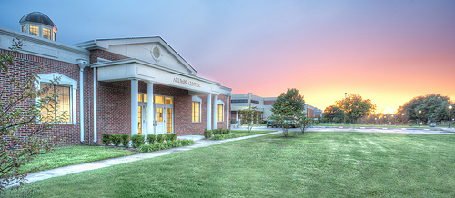

The Alumni Center is a focal point of activity to strengthen the bond among the University’s 60,000 alumni and to make a visible statement of the importance that the alumni play in the life of the University. The Alumni Center serves as the base for the alumni staff and their efforts will ultimately serve to strengthen relationships with current students, alumni, faculty and staff as well as visitors to the campus.

District Payment Instructions

All Payments are due by April 3, 2025.

Academic District Fee: $ 3,000.00

Please make payments online to:

<https://secure.touchnet.com/C20206_ustores/web/store_main.jsp?STOREID=142>

1. Click the UIL icon under products.
2. Enter the amount due ($3000) and click “add to cart”
3. Enter all schools in your district, email and phone for your contact, and proceed.
4. Click Checkout if the screen is correct, and then enter your payment method.

* Questions or concerns? Please contact Katy King, katykinguil@gmail.com