***Conference AA – Region I – Area 2***

***UIL One-Act Play contest***

***Saturday, April 6, 2019***

***Seminole High School***

***Hosted by Denver City ISD***

***Contest manager – Gary Davis***

*806-592-5951 (office); 806-592-1130 (cell)*

[*gary.davis@dcisd.org*](mailto:gary.davis@dcisd.org)

*Please email the following information to the contest manager by March 29, 2019 at 9:00 a.m.*

* *School name*
* *Director(s) name(s)*
* *Title of play*
* *District # (5, 6, 7 or 8) Bi-district # (A or B)*
* *Cell phone #*

***and***

***SUBMIT THE OFFICIAL UIL MACH FORM FOR THE AREA CONTEST.***

*http://www.uiltexas.org/theatre/area*

*Look for High School Area Contestant Entry Form 2018-19*

*Use this email address for the contest manager. gloria.mcluckie@dcisd.org*

*Director(s),*

*Congratulations on advancing from your Bi-District contest! You and your company are to be commended for your winning production. Denver City ISD and Seminole High School are pleased to serve as your hosts for the Conference 2A, Region I, Area 2 One-Act Play Contest on April 6, 2019. We hope this experience will be an enjoyable one for everyone participating.*

*Your company’s panel of critic judges for the day will be E. Don Williams (awards judge), Lynn Elms and Jonathon Marks. These adjudicators were assigned by the Texas Theatre Adjudicators Organization and the University Interscholastic League.*

*Upon advancing from your Bi-District contest, immediately send a published copy of your script to each judge at the addresses below, unless it is in public domain or an adaptation, noting all marked deletions and approved adaptations. Make three copies of the page addressed to the judges found in this packet and include it with your script.*

*Do NOT send the script via certified nor signature required mail. This will slow the delivery process.*

***E. Don Williams***

*4428 76th St.; Lubbock TX, 79424*

*Phone: 806-392-3295*

*E-mail:* [*don.williams@lcu.edu*](mailto:don.williams@lcu.edu)

***Lynn Elms***

*4605 18th Street****;*** *Lubbock TX, 79416*

*Phone: 806-787-9002*

*E-mail:* [*lynn.elms@ttu.edu*](mailto:lynn.elms@ttu.edu)

***Jonathon Marks***

*4012 92nd St.; Lubbock TX, 79423*

*Phone: 806-577-8789*

*E-mail:* [*jonathan.marks@ttu.edu*](mailto:jonathan.marks@ttu.edu)

***ELIGIBILITY OF STUDENTS:***

*By 11:59 pm on the Monday night immediately following your Bi-District contest, complete and submit the Area Contest Entry Form 2018-19.*

*http://www.uiltexas.org/theatre/area*

*This link can be found under Advancing Info at the bottom on the Area Meets page of the UIL Website. www.uiltexas.org This form must be completed to officially enter your students and set information for the Area contest. You will need this email address in order to complete the form: gary.davis@dcisd.org*

*ENTRY FEE: Directors will need to bring with them a check for $700.00 made payable to Denver City ISD. Use the attached invoice to request payment from your business office. You must bring the check with you to your school’s official rehearsal.*

***PLEASE BRING THE FOLLOWING TO YOUR REHEARSAL.***

1. *All correspondence from UIL approving scene items, special properties or clarifications.*
2. *Written evidence of paid royalty.*
3. *Publisher’s approval to produce a one-act or scenes from a long play (not required of plays in public domain.)*
4. *League approval to produce a one-act or scenes from a long play not found on the approved lists. (Not required of  plays in public domain, unless it is an adaptation.)*
5. *A signed “Community Standards and Copyright Compliance Form. http://www.uiltexas.org/files/academics/theatre/2016-  17_COMMUNITY_STANDARDS_AND_COPYRIGHT_COMPLIANCE_FORMRev11.pdf (Found under Resources and Forms of the UIL  Theatre website page.)*
6. *A signed and dated copy of the music log. http://www.uiltexas.org/theatre/resource-forms*
7. *A clearly marked “Integrity Script” (see below) reflecting the performance text and music cues. (This is in addition to  the scripts provided to the adjudicators.)*

***REHEARSAL SCHEDULE***

*The rehearsal schedule will be finalized once all qualifying schools have contacted the contest manager. Rehearsals shall be scheduled according to the performance order with the first show rehearsing first and the last show rehearsing last.*

*In your one-hour of rehearsal, your company will set, check/record light cues, set sound levels/strike. Please plan accordingly. It is strongly recommended that you practice your official rehearsal prior to the day of rehearsal.*

***ORDER OF PERFORMANCE****:*

*The Order of Performance was determined by a witnessed, blind draw with the letter "A" representing the title of play that comes first alphabetically from each district and the letter “B”, the title that comes second and the letter “C” the title that comes last, excluding articles. The plays will run back-to-back.*

*Show # Load-in Rehearsal*

***Friday, April 5, 2019***

*#1 4:00 pm 4:30 pm*

*#2 5:10 pm 5:40 pm*

*#3 6:20 pm 6:50 pm*

***Saturday, April 6, 2019***

*#4 8:00 am 8:30 am*

*#5 9:10 am 9:40 am*

*#6 10:20 am 10:50 am*

*Director’s meeting 12:00 pm - Fine Arts Department office*

*1. *1:00 Bi-District B (7/8) Title B*

*2. *1:50 Bi-District A (5/6) Title B*

*3. *2:40 Bi-District B (7/8) Title C*

*4. *3:30 Bi-District A (5/6) Title C*

*5. *4:20 Bi-District B (7/8) Title A*

*6. *5:10 Bi-District A (5/6) Title A*

*7:00 Awards presentation*

*7:15 Critique session 1*

*7:30 Critique session 2*

*Please note: In accordance with UIL rules, only directors, cast, crew and alternates that are listed on the area entry form are permitted in the dressing rooms. Alternates are not permitted backstage during the set, performance or strike times.*

***UNIT SET***

*The complete unit set will be available for use, including one door, one window and a set of French doors. Contact the contest manager should you need additional doors or windows. Everyone must use the basic set that is provided, including the in-house, intercommunications system.*

***SOUND***

*Each company is welcome to use the house system, but may bring your own sound equipment to operate backstage, if so desired. Seminole’s sound board has CD playback capabilities or you can run your sound from a computer or iPad. Each school will need to provide their own auxiliary cord(s) to run sound from your computer/iPad to the board.*

***LIGHTS***

*Seminole High School’s light board will be controlled by a single channel on the board. There will be blue and red washes. The cyclorama is lit with LED instruments, therefore any color can be achieved. Companies will have the option of recording their light cues during their one-hour scheduled rehearsal or running them manually. A Seminole ISD technician will be in the booth during each rehearsal and show to assist students should questions or difficulties arise. If you choose to record your light cues, it is highly recommended that you bring a flash drive for the storage of your cues as a back-up measure.*

***STAGE***

*Intercommunication head set stations are located SR, SL and two in the booth. In this packet is a diagram showing all drapery locations, stage dimensions and the light plot.*

*You will need to bring make-up mirrors for your use in your assigned dressing room.*

*If you have questions about the contest site, feel free to contact me at 806-592-1130 (cell), 806-592-5901 (office) or by email at gary.davis@dcisd.org.*

*Sincerely,*

*Gary Davis*

*Greetings Adjudicator!*

*You will be judging a production of this script at the*

***Conference 2A, Region 1, Area 2 contest***

*Seminole High School on April 6, 2019.*

*2100 NW Avenue D., Seminole, Texas 79360*

*Contest manager – Gary Davis*

*806-592-5951 (office); 806-592-1130 (cell)*

[*gary.davis@dcisd.org*](mailto:gary.davis@dcisd.org)

INVOICE

*Area One-Act Play Entry Fee*

*$700.00*

*Make check payable to:*

*Denver City ISD*

*Attention: Mr. Gary Davis*

*501 Mustang Drive; Denver City, TX 79323*

*Fed Tax ID: 756002455*

*Seminole PAC Light Plot*

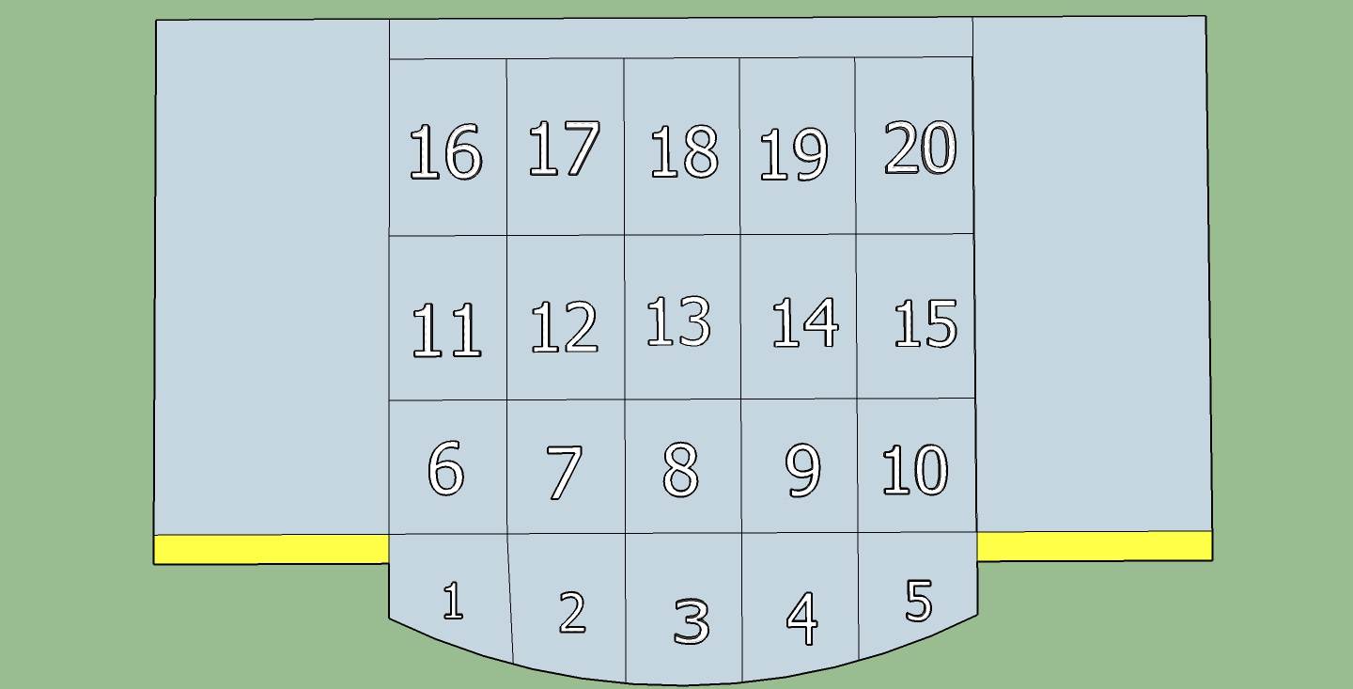

*Seminole PAC Stage Dimensions*

